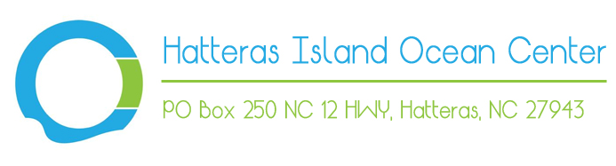

Hatteras Island Ocean Center Seasonal Internship
Internship Description
The Hatteras Island Ocean Center (HIOC) is looking for qualified interns for the Summer of 2015. HIOC runs outdoor/indoor programs geared towards kids and adults that are focused on ecotourism and environmental education. Interns at HIOC will be actively involved with all tasks related to daily operations for the Center. Interns will also help forward the Center's mission of revitalizing the local economy of Hatteras Village.
The intern should be prepared to work in a fast-paced team environment, and will finish the internship having gained broad experience in various aspects of running a nonprofit.
We are currently looking for interns with a background in:
- Biological Sciences
- Earth Sciences
- Education
- Marketing
- Park, Recreation, and Tourism Management
Tasks and Responsibilities
- Plan and implement weekly programs for kids and adults
- Assist with the daily operations of the Center (greet visitors, give tours of the facilities, and running the cash register at the gift shop, etc.,...)
- Assist in the planning and implementation of special events
- Assist directors in planning and implementing project(s) that furthers the goals of the organization
- Assist with the scheduling of volunteers
- Organize and clean program equipment
- Learn information about the flora/fauna and history of the area
Qualifications
- Have a passion for ecotourism and environmental education
- Must be outgoing and encourage conversations with visitors of all ages
- Excellent oral, written, and communication/presentation skills in front of individuals and groups
- Prefer a student in their Junior to Senior year
- Current CPR/First Aid Certification required
- Prefer GPA of 3.0 or higher
Compensation
- Housing is provided in an apartment above the Hatteras Island Ocean Center or at a nearby location
- Interns are given a $100/week stipend
Other Details
- Our internship is 12-weeks long and interns will be working a minimum 40 hours a week.
How to Apply
If interested in this internship, please email your cover letter and resume to info@hioceancenter.org.
We will contact you within a day or two and let you know that we received your information.

